**CURRICULUM VITAE**

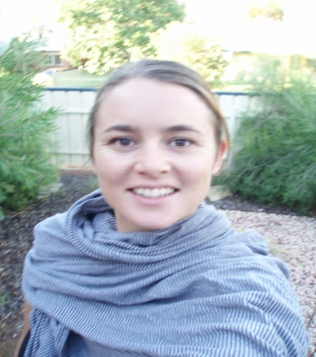

*Name:*  Katrina May

*Address:* Jalan Kemang V no.4

Kemang, Jakarta

*Phone:* 0813 1981 7445

*Email address:* [treenmay@gmail.com](mailto:Katrina.may@ntschools.net)

# **EDUCATION**

*2005* Latrobe University, Bundoora

DIPLOMA OF EDUCATION

*2002 – 2004* Latrobe University, Bundoora

BACHELOR OF ARTS – HUMANITIES

1994 Monash University, Clayton

BACHELOR OF BUSINESS SYSTEMS

*1988 – 1993*  Aquinas College, Ringwood

VICTORIAN CERTIFICATE OF EDUCATION

# **PROFESSIONAL REFEREES**

**1. Henri Bemelmans Head of Campus, AIS**

Email: Henri.bemelmans@ais-indonesia.com

**2. Jill Batty Faculty Leader - English/Humanities**

Email: jill.batty@ais-indonesia.com

**3. Inga Tamou Deputy Head of Campus, AIS**

Email: inga.tamou@ais-indonesia.com

## **WORK HISTORY**

*Jan 2011 - present*  Australian Independent School, Pejaten

**As an English, Humanities and TOK teacher my role includes:**

* Teaching English to years 7-10 following the Australian Curriculum
* Teaching Humanities to years 7-10 following the Australian Curriculum
* Teaching TOK to years 11 and 12
* Running professional development related to areas such as TOK across the curriculum and OPVLs in history
* Writing programs which incorporate enquiry and collaboration
* Working collaboratively as a small school to develop high quality resources
* Building confidence in my students in an inclusive environment
* Creating differentiated materials
* Developing programs which engage student interest
* Maintaining positive relationships with parents, students and colleagues
* Completing professional development
* Developing service learning projects across the curriculum

*April 2009 – present* Superkids, Kemang

LANGUAGE ARTS TEACHER

**As the Language Arts Teacher, my role included:**

* Teaching classes of students aged 2 – 5, using the THRASS program
* Coordinating classes and events
* Supporting staff with ESL development
* Writing and presenting parent educational seminars on literacy
* Writing and editing a bi-term newsletter
* Speaking with parents daily regarding child development and curriculum
* Reporting each semester on individual child’s development
* Speaking with potential parents about the school and facilities
* Supporting staff with IT
* Creating presentations and reports on the school
* Teaching ESL adult classes after school hours

*Feb 2007 – April 2009* Alice Springs High School and Anzac High School

ACCELERATED LITERACY COORDINATOR

**As the Accelerated Literacy Coordinator, my role included:**

* Teaching classes using methods of Accelerated Literacy
* Giving demonstration lessons in the teaching of the program for new teachers
* Informing and meeting with the school community and other stakeholders to plan the implementation of Accelerated Literacy at ASHS
* Supporting Anzac High School Staff in administering tests and ensuring that the program continued to run successfully
* Undertaking the required AL professional development
* With DEET AL Team feedback, teaching AL in order to gain expertise
* Leading frequent AL teacher meetings to jointly plan & prepare teaching programs
* Training and mentoring others including giving informal feedback on observed lessons

**tact:**

*Jan 2006 – Dec 2007* Alice Springs High School

*SOSE/ENGLISH/*ESL/ESD TEACHER

**As the SOSE/ENGLISH/ESL/ESD Teacher, my role included:**

* Teaching and assessing SOSE and English utilizing the Northern Territory Curriculum
* Identifying all ESL/ESD students
* Supporting all ESL/ESD across the subject areas
* Supporting teachers in program planning
* Tracking 50 students across the year
* Reporting on students mid-term and at the end of term
* Working to support students in and outside of the classroom
* Planning each term across the KLAs to support teachers, as well as planning my own classes

Feb 2005 – Oct 2005 Fitzroy Learning Network

CLASSROOM SUPPORT FOR ESL LEARNERS

*Nov 2004 – Feb 2005* Social Security Appeals Tribunal, Melbourne

ADMINISTRATION OFFICER/RECEPTION

## **INTERESTS** Research, Sociology, Anthropology, travel, meeting new people, music, film